FORM-XIII
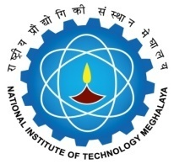

National Institute of Technology Meghalaya

(Format for Certificate of the Supervisor(s))

This is to certify that the thesis entitled _______________________________ submitted by Mr./ Ms. __________________________ in partial fulfillment of the requirements for the award of the degree of Doctor of Philosophy in ___________________________ is a record of research work carried out by him/ her under my/ our supervision and guidance.

All help received by him/ her from various sources have been duly acknowledged.

No part of this thesis has been submitted elsewhere for award of any other degree or diploma.

Signature of Signature of

Co-Supervisor: Supervisor:

Designation: Designation:

Department: Department:

