FORM-XII

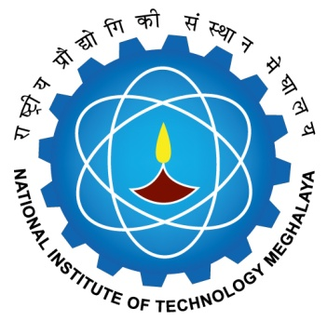

NATIONAL INSTITUTE OF TECHNOLOGY MEGHALAYA
बिजनी कॉम्‍पलेक्‍स, लैटमुख्‍्राह, शिलांग Bijni Complex, Laitumkhrah, Shillong-793003

REPORT OF EXAMINERS OF ORAL DEFENCE EVALUATION COMMITTEE

Name of the Scholar:
Roll no:
Department:
Title of the thesis :
Date of ODE:
The examiners of Oral Defence Evaluation Committee (ODEC) certify that the thesis mentioned above submitted by __________________________________ to the NIT Meghalaya in partial fulfillment of requirement of the Ph.D degree in the discipline of _______________________________________________________ has been examined by us and we recommend that (please tick the one relevant) ;
- The degree be awarded  OR | ☐
- We recommend that the candidate be examined further on another date not later than________  OR | ☐
- The candidate has not performed to our satisfaction and does not deserve the degree of Ph.D | ☐

Name & Signature of the ODEC members:
______________________  Chairman (Name) - | ______________________  Indian Examiner (Name) -
______________________  External DC Member (if any) (Name) - | ______________________  Member (Name) –
______________________  Member (Name) – | ______________________  Member (Name) –
______________________  Member (Co-Supervisor) (Name)- | ______________________  Convenor & Supervisor (Name) -

Signature of DRC Chairman
Date:

Forwarded to Dean(AA)
Remarks by Dean (AA)

Dean (AA)

Approval for Provisional certificate

Director

